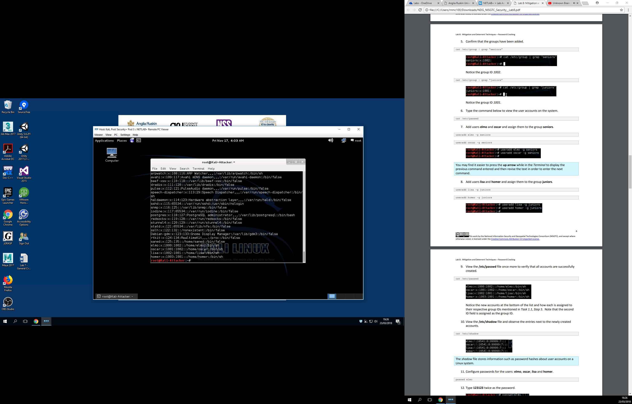

Here we just created the new users for each group, and checked if they had passwords.

Now populated with passwords

